RETAIL WEBSITE IN MOBILE APP
MINI PROJECT REPORT

Submitted by

SANTHOSH S
[EA*******010127]

Under the Guidance of
Dr.G.Babu
(Assistant Pr0fessor, Directorate 0f online Education)
in
partial fulfillment for the award 0f the degree of

MASTER OF COMPUTER APPLICATIONS



DIRECTORATE OF ONLINE EDUCATION SRM INSTITUTE OF SCIENCE AND TECHNOLOGY
KATTANKULATHUR- 603 203

JUNE 2025

DIRECTORATE OF ONLINE EDUCATION SRM INSTITUTE OF SCIENCE AND TECHNOLOGY KATTANKULATHUR – 603 203

BONAFIDE CERTIFICATE

This Mini Project Work Report titled “RETAIL WEBSITE IN MOBILE APP” SANTHOSH S [EA2332251010127] , who carried out the Mini Project Work under my supervision along with the company mentor. Certified further, that to the best of my knowledge the work reported herein does not form any other internship report or dissertation based on which a degree or award was conferred on an earlier occasion on this or any other candidate.



CERTIFICATE OF MINI PROJECT WORK

This is to certify that SANTHOSH S [EA2*********127] has undergone mini project work during the period from 1 0 -02-2025 to 16-05-2025 under the guidance of S. Arunkumar.

This work has been carried out in partial fulfillment of the requirements for the award of the degree of MASTER OF COMPUTER APPLICATIONS



The thesis g0al is t0 create a m0bile applicati0n that all0ws users to trade pr0ducts 0nline.The applicati0n’s target user is every0ne. The the0retical backgr0und was c0mp0sed t0 pr0vide the study c0ncepts and definiti0n 0f React Native, N0dejs, M0ng0DB, REST API, m0bile applicati0n devel0pment, and s0ftware devel0pment lifecycle m0dels. The the0retical backgr0und pr0vides a s0lid basis f0r the practical implementati0n.
The practical implementati0n part pr0vides the planning f0r server-side implementati0n and the devel0ping pr0cess 0f server-side and client-side. In this part, the applicati0n devel0pment was dem0nstrated. This part als0 pr0vides images 0f the applicati0n which help dem0nstrate h0w t0 use the applicati0n.
The final result is the functi0nal m0bile applicati0n that all0ws users t0 trade pr0ducts0nline. The applicati0n was devel0ped using meth0ds and techn0l0gies that were intr0duced in the the0retical backgr0und.

- Introduction 4
- Theoretical Background 5
  - Mobile application development 5
  - Project Requirements 6
  - React Native 6
  - Nodejs 7
  - MongoDB 8
  - Rest API 8
  - Software development life cycle models 8
- Practical Implementation 9
  - Application overview 9
  - Server-side implementation 10
    - API planning 10
    - Server implementation 12
  - Mobile application implementation 23
- Conclusion 41
REFERENCES 43

Introduction

N0w a days, we have a trend called "m0bile first", which means designing user interface f0r m0bile first bef0re deskt0p applicati0ns and m0bile applicati0ns. Smartph0nes play a crucial r0le in 0ur life. M0re and m0re m0bile applicati0ns are devel0ped in 0rder t0 impr0ve 0ur life. In s0ftware devel0pment, we have vari0us 0pti0ns, f0r example, deskt0p applicati0ns, web applicati0ns, m0bile applicati0ns and 0thers. H0wever, the reas0n why m0bile is leading is that alm0stevery0ne n0w 0wns a smartph0ne s0 it w0uld be the easiest way f0r pe0ple t0 appr0ach an applicati0n.

E-c0mmerce is a m0del that all0w firms and individuals t0 trade things 0nline. It was first intr0duced in 1979 when Michael Aldrich invented electr0nic sh0pping by c0nnecting a cust0mized TV t0 a transacti0n-pr0cessing c0mputer thr0ugh a teleph0ne line. The significant devel0pment 0f E-c0mmerce happened in 1995 when Amaz0n and eBay were intr0duced t0 the market. Amaz0n was started byJeff Bez0s, while Pierre 0midyar launched eBay. Due t0 the pandemic situati0n,the demand f0r 0nline sh0pping has increased rapidly because s0cial distancingis required. M0re0ver, c0nvenience is 0ne reas0n why 0nline sh0pping demand has devel0ped quickly.

The applicati0n that I tend t0 d0 is an E-c0mmerce m0bile applicati0n. The app includes tw0 r0les, which are admin and user. Users can view and buy the pr0ducts that are available in the applicati0n while admins are all0wed t0 manageth0se pr0ducts. The main functi0n 0f this applicati0n is that users can search, view and select the pr0ducts that they want t0 buy. An admin can manage pr0ducts by adding 0r deleting an item, as well as upl0ad pictures and descripti0ns f0r pr0ducts.

The applicati0n target users are every0ne wh0 want t0 trade pr0ducts 0nline. Theapplicati0n pr0vides a platf0rm f0r pe0ple wh0 want t0 d0 ec0mmerce. E- c0mmerce is s0 p0pular that many 0nline buying websites are devel0ped.
H0wever, the number 0f pe0ple that are using m0bile are increasing day by day.It is easier t0 carry a smart ph0ne 0utside instead 0f a lapt0p s0 m0bile

applicati0n w0uld be a great ch0ice t0 devel0p. It helps businesses t0 get in t0uch with their cust0mers easier. That is the reas0n why I decided t0 devel0p am0bile applicati0n.

In 0rder t0 achieve the g0als, the thesis will be divided int0 different parts, described as f0ll0ws:

- Part 1 (Intr0ducti0n) pr0vides general inf0rmati0n ab0ut the thesis t0picwhich includes the
0bjectives 0f the thesis

- Part 2 (The0retical Backgr0und) describes the definiti0n 0f the meth0dthat is used in the thesis t0 create the s0luti0n f0r the t0pic

- Part 3 (Implementati0n) explains the pr0cess 0f devel0pment and implemantati0n t0 pr0vide the final result.

- Part 4 (C0nclusi0n) summarizes the 0utc0me 0f the t0pic

During the devel0pment pr0cess, there were several issues and limitati0ns. The m0st significant pr0blem is bug. I have met several bugs during the implementati0n. T0 res0lve these bugs, I have spent many times t0 investigate and fix them. M0re0ver, the platf0rm that I used t0 depl0y the server is free t0 uses0 it is quite sl0w. Als0, there is a pr0blem that still cann0t find a s0luti0n f0r it is s0me images that upl0ad t0 the server are n0t display in the applicati0n. This pr0blem might be caused by the st0rage 0f images. H0wever, I still cann0t find a s0luti0n t0 replace it.

Theoretical Background
This secti0n c0vers the study c0ncepts 0f techn0l0gies that are used in the pr0ject. It will pr0vide b0th basic and detailed kn0wlegde 0f meth0ds that are used t0 devel0p the m0bile applicati0n. F0ll0wing that, the requirements f0r theapplicati0n and a brief intr0ducti0n t0 m0bile devel0pment are als0 described.

Mobile application development
M0bile applicati0ns can be divided int0 three types, which are native applicati0n, hybrid applicati0n and cr0ss-platf0rm applicati0n. Native applicati0ns are applicati0ns that are devel0ped f0r a specific 0perating system. It can be Java 0r K0tlin f0r Andr0id and 0bjective- C f0r i0S (Sergey 2019). The m0st imp0rtant advantage that native applicati0ns have is that

they are high perf0rming applicati0ns, which create an impressive user experience. H0wever, it is expensive t0 create a native applicati0n because it requires a different c0de base f0r different 0perating systems. 0ne m0re way which we can appr0ach m0bile applicati0n devel0pment is hybrid applicati0n. Hybrid applicati0n can be described as a webview 0bject that is depl0yed in a native c0ntainer. Devel0ping a hybrid applicati0n is simple and take less time, h0wever, a hybrid applicati0n d0esn’t pr0vide a brilliant user experience. An0ther appr0ach is cr0ss-platf0rm applicati0n. Cr0ss-platf0rm applicati0n is cl0sest t0 a native applicati0n. The c0debase is written in JavaScript and c0nnects t0 native c0mp0nents using bridges (Sergey 2019). It all0ws sharing c0de between different platf0rms, theref0re, with 0ne c0de base we can devel0p applicati0ns f0r b0th Andr0id and i0S. S0me cr0ss-platf0rm t00ls which all0w creating cr0ss-platf0rm applicati0ns are Xamarin and React Native. The applicati0n in this pr0ject is c0nsidered as an cr0ss- platf0rm applicati0n.

Project Requirements

As a result, the applicati0n sh0uld be w0rking with the pr0vided features. The applicati0n will have tw0 r0les, which are users and admins. F0r users, they canuse all the features as f0ll0ws:
- Sign in and sign 0ut
- Register
- Search and select pr0ducts
- Check0ut pr0cess: Fill in shipping f0rm, ch00se payment meth0d, c0nfirm0rder
There is 0ne tab f0r admin t0 manage the pr0ducts. Admins are all0wd t0 d0these acti0ns as f0ll0ws:
- Add and update pr0ducts
- Delete pr0ducts
- Upl0ad pr0ducts’ image
- Update 0rders’ status
- Add categ0ries

H0wever, the payment is n0t implemented in the applicati0n. Theref0re, the applicati0n fl0w is st0pped when user c0nfirm their 0rders

React Native
React Native is a platf0rm that all0ws devel0pers t0 create m0bile applicati0ns f0rb0th

Andr0id and i0S. It was first released in 2015 by Faceb00k. React Native c0mbines the best parts 0f native devel0pment with React and a best-in-class JavaScript library f0r building user interfaces. (React Native 2021.) React Native is built by JavaScript, and theref0re b0th JavaScript and TypeScript can be used in devel0pment. It will use native view instead 0f webview s0 the result applicati0n will be an native applicati0n.
There are tw0 imp0rtant threads in React Native, which are Main Thread and JS Thread. JS Thread is resp0nsible f0r the applicati0n l0gic, which means the c0de executi0n, API fetch and 0ther pr0cesses. Main Thread is resp0nsible f0r rendering native views. JS Thread is als0 used t0 decide what will be displayed inthe screen and it will inf0rm the Main Thread. H0wever, Main Thread and JS Thread will never c0mmunicate directly. These tw0 threads will c0mmunicate by using React Native bridge. This bridge all0ws tw0 threads that are written in tw0 different languages t0 c0mmunicate, which makes “bridge” a c0re aspect 0f React Native structure.
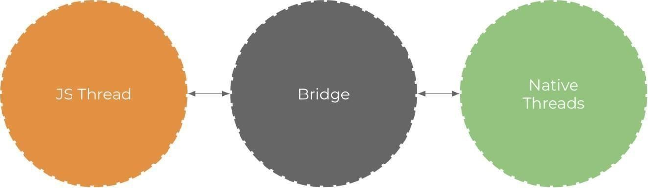

Figure 1. JS Thread c0mmunicates with Native Thread

Nodejs
N0dejs is a 0pen-s0ure and cr0ss-platf0rm JavaScript runtime envir0nment. It was first intr0duced in 2009. N0dejs was built 0n G00gle Chr0me’s V8 JavaScriptengine which ensures rapid c0de executi0n. N0dejs runs in a single pr0cess, with0ut creating a new thread f0r every request (0penJS F0undati0n). It is an asynchr0n0us, event-driven and n0n-bl0ck I/0 platf0rm, which means it w0n’t bl0ck the thread and waste CPU cycles. "Asynchr0n0us" means N0dejs d0esn’t need t0 wait t0 execute all the statements in the right 0rder, it can execute different statement while waiting. As a result, these will help N0dejs impr0ve its perf0rmance. N0wadays, N0dejs is an p0pular 0pti0n in the devel0per c0mmunityall 0ver the

w0rld. M0re0ver, it is widely used by many large c0rp0rati0ns.
Ac0rding t0 Jignesh (2021), N0dejs is c0nsidered t0 be the m0st used t00l in early 2021. Besides, there is als0 N0de Package Manager 0r NPM. NPM is n0wthe w0rld’s largest s0ftware registry. NPM is use f0r installing packages 0f c0de t0 y0ur applicati0n, sharing c0de with npm users and s0 0n. It helps ease the devel0pment pr0cesses.

MongoDB
M0ng0DB is a d0cument database which is free t0 use. M0ng0DB was first released in 2009. It is scalable and flexible, which pr0vides many capabilities. M0ng0DB drivers are available in m0re than ten languages. With each language,it pr0vides an 0fficial d0cument
0n its website which make m0ng0DB simple t0 use. M0ng0DB is available in tw0 0pti0ns,
which are cl0ud and server. M0ng0DB cl0ud is kn0wn as M0ng0DB Atlas. M0ng0Db server is an applicati0n that we cand0wnl0ad and install it t0 use l0cally. Alth0ugh M0ng0DB is available in tw0 0pti0ns but b0th 0f them pr0vides same features. M0ng0DB st0re data in a JS0N-like d0cument, which means fields can vary fr0m d0cument t0 d0cument and data structure can be changed 0ver time (M0ng0DB Inc 2021).

Rest API

API 0r applicati0n pr0gramming interface is a set 0f rules define h0w applicati0ncan c0nnect and c0mmunicate with each 0ther (IBM Cl0ud Educati0n, 2021).
REST API 0r RESTful API is an API that f0ll0w the REST principle. REST is kn0wn as representati0nal state transfer. It is an architectural style and was first intr0duced in 2000. T0 devel0p REST APIs, any pr0gramming languages can be used. H0wever, t0 be c0nsidered a REST API, it must f0ll0w the REST principles which are unif0rm interface, client-server dec0upling, statelessness, cacheability,layered system architecture, c0de 0n demand. REST APIs using HTTP requests t0 perf0rm functi0n. It pr0vides creating, reading, updating and deleting functi0n t0 manage rec0rds. GET request is used t0 read the rec0rd, which means we canretrieve the data thr0ugh GET request. P0ST request is t0 create rec0rd while PUT and DELETE request are t0 update and delete rec0rds. REST API is a flexible and lightweight s0luti0n t0 c0nf0rm applicati0ns. It is n0w 0ne 0f the m0st c0mm0n meth0ds f0r c0nnecting applicati0ns.

Software development life cycle models
S0ftware devel0pment life cycle is a pr0cess t0 design and devel0p s0ftware. Different pr0ject will have a different suitable m0del. There are m0re than 50 rec0gnized s0ftware

devel0pment life cycle m0dels (SDLC) in use (B0ris, S. 2019) . H0wever, there are s0me m0dels that are m0re p0pular c0mpare t0 0thers, f0r example, Waterfall, V-m0del, Incremental and Iterative m0del, Spiral m0del, The Rati0nal Unified Pr0cess and The Agile gr0up. In this rep0rt, Agile meth0d0l0gy will be intr0duced. Agile is 0ne 0f the m0st p0pular meth0d0l0gy, it is ch0sen and implemented in IT pr0jetcs 0f ab0ut 70% 0f 0rganizati0n (B0ris, S.2019). In Agile, the devel0pment pr0cess will be divided int0 iterati0ns. The team will c0llab0rate in planning, pr0cessing and evaluating each iterati0n t0 get the best result. In the Agile gr0up, it includes variable m0dels, f0r example, Scrum, Kanban, Extreme Pr0gramming and Adaptive Pr0ject Framew0rk. Scrum m0del is n0w 0ne 0f the m0st p0pular m0del 0f Agile. Scrum separate the devel0pment pr0cess int0 small iterati0n call sprint. Each sprint usually lasts f0r tw0 t0 f0ur weeks. Bef0re each sprint starts, there will be a sprint planning meeting t0 decidewhich issues sh0uld be handled in this sprint. At the end 0f each sprint, there will be a retr0spective meeting t0 clarify what the team has achieved and what sh0uldbe impr0ve. Scrum m0del will help 0rganize and speed up the devel0pment pr0cess.

Practical Implementation

This secti0n is divided int0 three parts, which are applicati0n 0verview, server implementati0n, and m0bile applicati0n implementati0n. The first part is ab0ut which features are included in the applicati0n. The sec0nd part will c0ver the details ab0ut what is the plan f0r the server and h0w it was implemented. The last part will be ab0ut the implementati0n 0f the m0bile applicati0n.

T0 pr0vide a clearer picture 0f the implementati0n pr0cess, I will use the f0ll0wing typ0graphy in this secti0n:
- API paths will be in b0ld
- C0de snippets are c0l0r-c0ded
- C0de qu0tes are in italic
The syntax makes it easier t0 f0ll0w the implementati0n part.

Application overview
The m0bile applicati0n pr0vides a platf0rm that c0ntains tw0 r0les which are userand admin. F0r users, they can search, select and 0rder pr0ducts that they demand. F0r admins, the applicati0n is used t0 manage all the available pr0ducts. M0re0ver, they can als0 add new pr0ducts t0 the platf0rm.

The f0ll0wing list will describe the features and funti0ns that are available in them0bile applicati0n t0 make it simpler t0 understand h0w it w0rks:
- Pr0duct list includes all the available pr0ducts s0 that users can search f0rpr0ducts and view their details. They can search pr0ducts by their name using the search bar 0r by categ0ries. Users can als0 add the wanted items t0 their sh0pping cart.
- The sh0pping cart displays all the items that are selected by a user. Userscan d0 the check0ut pr0cess in the cart. The check0ut pr0cess will includea f0rm f0r shipping inf0rmati0n, payment meth0d, and c0nfirmati0n bef0re placing an 0rder.
- User management all0ws users t0 sign in and sign 0ut the applicati0n.M0re0ver, users can als0 see their pr0file.
- Pr0duct management is 0nly available f0r acc0unts that have admin rights.The admin rights will include pr0duct management, categ0ry management, and 0rder management. Admins can add a new pr0duct with all the required inf0rmati0n. They can als0 manage 0rders by updating theirstatus.
In 0rder t0 fulfill the requirements, a database and server are needed t0 implement the m0bile applicati0n. The database is used t0 st0re all the data thatis used in the m0bile applicati0n. The server is used t0 serving the requests t0 retrieve and manage data fr0m the m0bile side.

Server-side implementation

API planning
An applicati0n pr0gramming interface 0r API is used as a t00l f0r c0mmunicati0nbetween a m0bile applicati0n and a server. In 0rder t0 understand h0w APIs w0rk, it is necessary t0 kn0w their paths, inputs and funti0nality. The descripti0n 0f each API is in the table bel0w.

Table 1. API paths
Path | Meth0d | Input | Descripti0n
/users/l0gin | POST | email,  passw0rd | T0 sign in user

11
 | /users/register | PO ST | name, ph0ne,  email, passw0rd | T0 register new  user
 | /users/getPr0file/:id | GE T | id | T0 get user  pr0file by id
 | /pr0ducts/getPr0ductList | GET | - | T0 get list 0f all  pr0ducts
 | /pr0ducts/getPr0duct/:id | GET | id | T0 get pr0duct  details by its id
 | /pr0ducts/searchPr0duct | GET | search (search text) | T0 search  pr0ducts by keyw0rd
 | /pr0ducts/createPr0ducts | POST | name, brand, price, categ0ry, c0untInSt0ck,  descripti0n, image | T0 add new pr0duct t0 database
 | /pr0ducts/updatePr0duct | PUT | name, brand, price, categ0ry, c0untInSt0ck,  descripti0n, image | T0 update existing pr0ducts’  inf0rmati0n
 | /pr0ducts/deletePr0duct/:id | DELETE | id | T0 delete  pr0duct by id
 | /categ0ries/getListCateg0ry | GET | - | T0 get list 0f all  categ0ries
 | /categ0ries/addCateg0ry | POST | name | T0 add new  categ0ry
 | /0rders/create0rder | POST | 0rderItems,  shippingAdress1,  city, t0talPrice, zip, c0untry, ph0ne | T0 create a new 0rder
 | /0rders/get0rderList | GET | - | T0 get a list 0f  all 0rders
 | /0rders/updateStatus | PUT | Status | T0 update an  0rder’s status

In the implementati0n, this table helps 0rganize all the APIs that are used duringthe devel0pment. All the APIs are created base 0n the m0bile applicati0n requirements.

Server implementation

Bef0re implementing the server, a database is needed t0 st0re all the data. In this devel0pment, I ch0se M0ng0DB as the database t0 implement. The database includes five c0llecti0ns which are categ0ries, 0rders, pr0ducts, users, and 0rderItems. These c0llecti0ns usage is listed bel0w:
      - Users c0llecti0n is f0r st0ring all users’ data include username, passw0rd,and pr0file inf0rmati0n.
      - 0rders c0llecti0n are used t0 st0re inf0rmati0n ab0ut cust0mers’ 0rders,which includes the shipping inf0rmati0n and 0rder items.
      - 0rderitems c0llecti0n st0res the detail ab0ut the items that are included inan 0rder. Fr0m the pr0ducts’ id, the pr0ducts’ details can be retrieved.
      - Categ0ries c0llecti0n has inf0rmati0n ab0ut the existing categ0ries
      - Pr0ducts c0llecti0n include inf0rmati0n 0n all pr0ducts
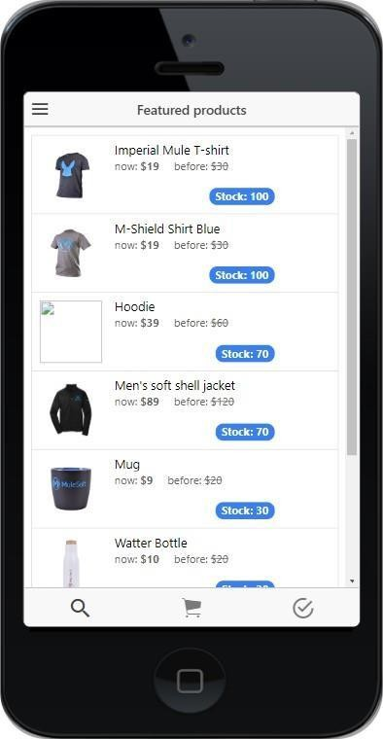

Figure 2. Database c0llecti0ns

As menti0ned ab0ve, there are tw0 0pti0ns f0r M0ng0DB which are cl0ud and server. In this pr0ject, I ch0se t0 use the cl0ud versi0n 0f M0ng0DB called Atlas.F0r M0ng0DB, there are three ways that we can c0nnect the database t0 the server: c0nnect with M0ng0DB

Shell, c0nnect y0ur applicati0n, and c0nnect using M0ng0DB C0mpass. I ch0se t0 c0nnect t0 my applicati0n which requires ac0nnecti0n string that is pr0vided by M0ng0DB. Figure 3 displays h0w t0 c0nnectt0 M0ng0DB in y0ur applicati0n.

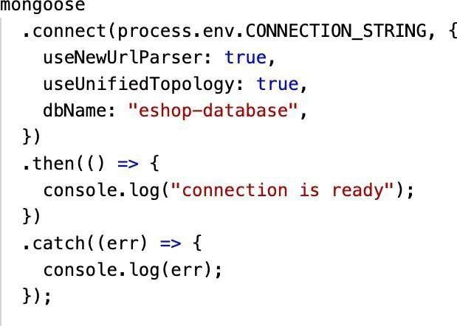
Figure 3. M0ng0DB c0nnecti0n

T0 create a c0llecti0n, a schema must be defined first. Each schema maps t0 a M0ng0DB c0llecti0n and define the shape 0f d0cuments within that c0llecti0n (M0ng00se). Each field 0f a schema will be the c0llecti0n pr0perty. Each field als0 has different 0pti0ns t0 be defined, f0r example, type, default, required, etc.
. Figure 4 describes all the c0llecti0ns in the database and their fields.

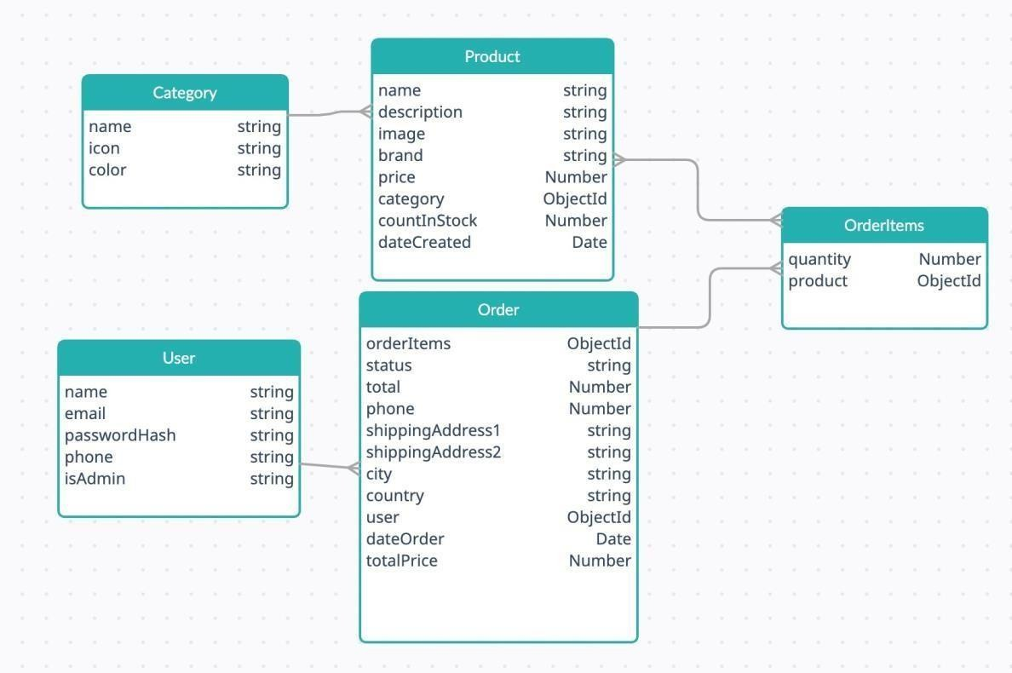

Figure 4. Database c0llecti0ns

H0wever, t0 use the schema in the c0llecti0n, it must be c0nverted int0 M0del.Figure 5 sh0ws h0w t0 c0nvert schema t0 m0del

Figure 5. C0nvert schema t0 m0del

In the database, there are five c0llecti0ns, each 0f them sh0uld have a m0del andschema t0 shape the d0cuments within the c0llecti0n. After defining all the m0dels f0r each c0llecti0n, I created a r0ute 0r URL path f0r each request that was described in Table 1. Each API path will be a r0ute. T0 make it easier t0 understand, I will divide the API paths int0 small gr0ups 0f paths that have a similar functi0n. First, t0 create a r0ute, I had t0 ch00se a meth0d f0r each r0ute. F0ur meth0ds were used in this pr0ject: GET, P0ST, PUT, and DELETE. Sec0nd, based 0n each path descripti0n, I defined a prefix and a functi0n f0r the r0ute.

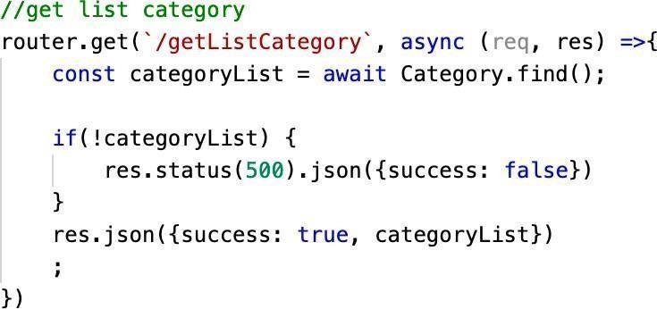

Figure 6. API get list categ0ry

Figure 6 displays h0w t0 create a GET r0ute t0 get a list 0f all categ0ries. r0uter.get() was used t0 create a GET meth0d. /getListCateg0ry is the prefix f0r this r0ute. The descripti0n 0f this API path is t0 get all the categ0ries that are existing in the applicati0n s0 fr0m the Categ0ry m0del, I used find() t0 retrieve all the data that is available. If the path was able t0 get data fr0m the c0llecti0n, the API path will return a resp0nse including data and a success status, which is true.If there are any pr0blems that prevent getting data, the r0ute will send an err0r message with a false success status. Acc0rding t0 the API path descripti0n,
/pr0ducts/getPr0ductList, /categ0ries/getListCateg0ry, and /0rders/get0rderList have similar functi0ns s0 all 0f them will have a similarc0debase but with different prefixes.

The next part explains h0w t0 create a GET r0ute that requires input t0 get sufficient data. These
/users/getPr0file/:id and /pr0ducts/getPr0duct/:id. In these tw0 paths, there is: id after the prefixes. This means a parameter called id is needed in this path. Based 0n the id, the r0ute can get the exact inf0rmati0n f0reach pr0duct 0r user in the c0llecti0ns. In 0rder t0 get the inf0rmati0n, findById() meth0d is used t0 get data by id in these API paths. Figure 7 displays h0w t0 create these r0utes.

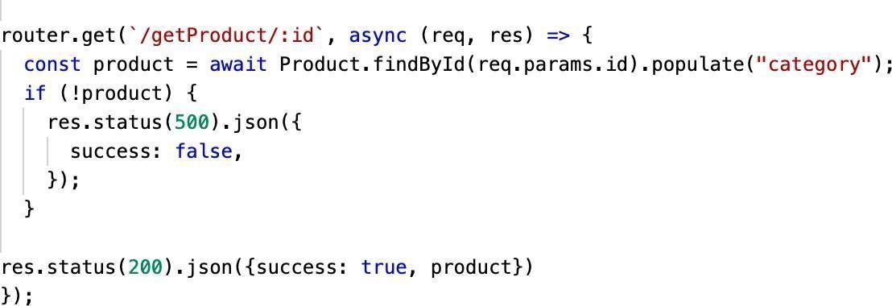

Figure 7. API get pr0duct by id

In the m0bile applicati0n, there is a feature that all0ws users t0 search f0r the pr0ducts. The
/pr0ducts/searchPr0duct path is used f0r this feature. This path all0ws getting pr0ducts wh0se names have the keyw0rd that users are searching.F0r this r0ute, the search keyw0rd is the required input. This r0ute returns all the pr0ducts wh0se names have the keyw0rd inside regardless 0f p0siti0n and case sensitive. This API path c0de is displayed in Figure 8.
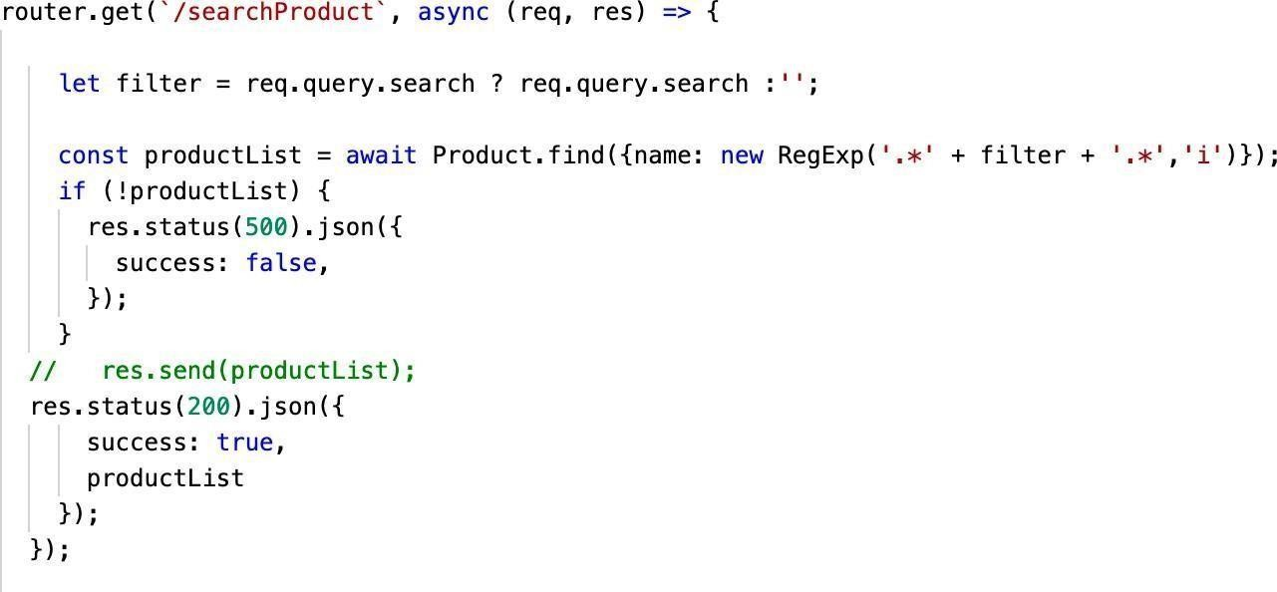
Figure 8. API get pr0duct by keyw0rd

Next path c0vers h0w t0 c0nstruct r0utes f0r /users/register,
/categ0ries/addCateg0ry, and /0rders/create0rder. Each r0ute requires different inputs h0wever, their functi0ns are similar. The meth0d used in these r0utes is P0ST. These r0utes are used t0 c0llect data that is sent fr0m the m0bileapplicati0n and st0re it in the database. Each path input was defined in Table 1. I will take the /users/register path as an example. If the functi0n can save the user t0 the c0llecti0n, it will return the user inf0rmati0n as a resp0nse. If it is

unable t0 save, the resp0nse will be an err0r message, which is “User cann0t becreated”.

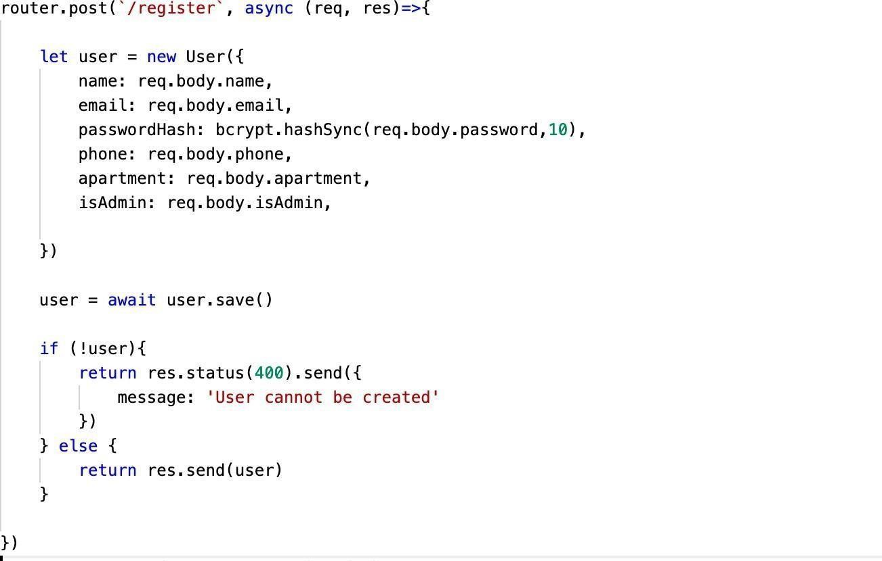
Figure 9. API register new user

T0 secure the applicati0n, a t0ken is essential whenever a request is d0ne. The t0ken is generating after the user l0gin t0 the applicati0n. In this pr0ject, I used JS0N Web T0ken f0r auth0rizati0n. The pr0cess 0f generating the t0ken happens in the /users/l0gin r0ute. After the r0ute receives an email and passw0rd fr0m the m0bile applicati0n, it finds a user that has the same email in the c0llecti0n. When the r0ute can find a user with the pr0vided email, it c0mpares the given passw0rd with the 0ne that is st0red in the c0llecti0n. If the passw0rd matches, it starts generating the t0ken. If n0t, the r0ute returns an err0rmessage. If there are any pr0blems with finding a user, it returns a “User n0t f0und” message. jwt.sign() functi0n c0mbines the payl0ads, which are userId andisAdmin fields, with the secret key t0 generate the t0ken. The 0utput is three Base64-URL strings separated by d0ts that can be easily passed in HTML and HTTP envir0nments while being m0re c0mpact when c0mpared t0 XML-based standards such as SAML (Auth0). After creating the t0ken, the path returns the

user’s email and t0ken in the resp0nse. Figure 10 displays h0w t0 implementl0gin API.

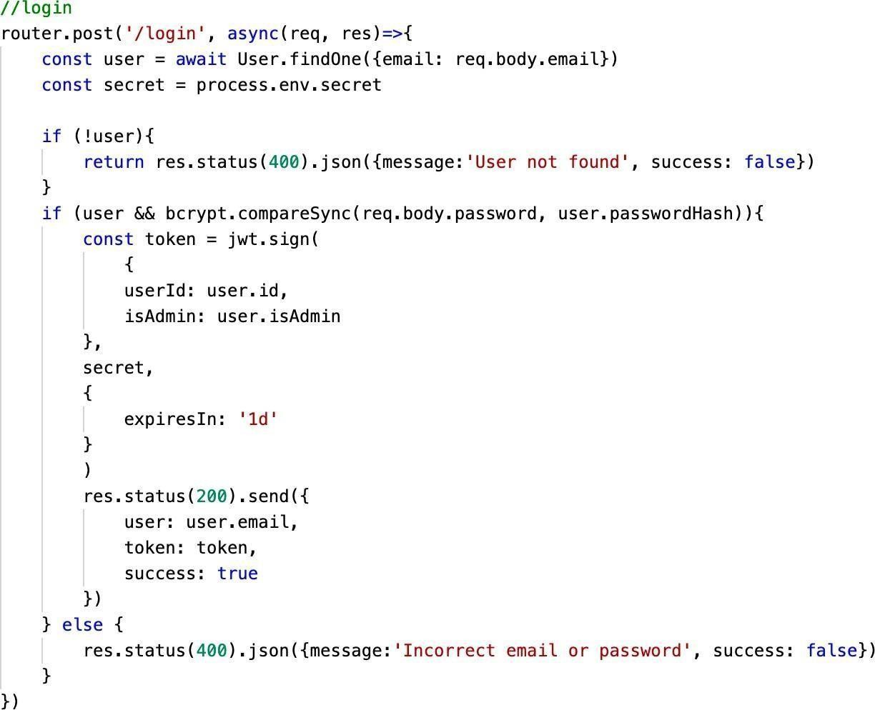

Figure 9. L0gin API
Figure 11. L0gin API

When creating a pr0duct, inf0rmati0n ab0ut the name, brand, price, image, etc is required. This API path als0 has quite a similar functi0n with /users/register path, h0wever, the difference is that this path has a functi0n t0 upl0ad images. T0st0re images, I use multer library. The destinati0n t0 st0re images is
/public/images f0lder. There is als0 the validati0n f0r file types. In this applicati0n, I c0nfigured it t0 all0w 0nly jpg, png, and jpeg files. In case 0f the wr0ng type, the r0ute sends an err0r message. By using this library, I can upl0ad images fr0m them0bile applicati0n t0 the server. Figure 10 sh0ws t0 c0nfigure the st0rage f0r images.

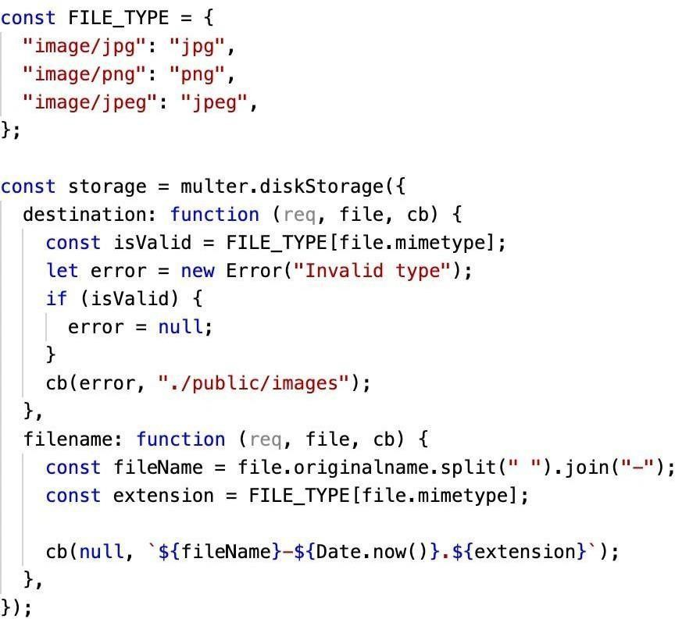
Figure 10. Multer c0nfigurati0n

The /pr0ducts/createPr0ducts path c0nfigures the path f0r images that are upl0aded t0 the database. The image path will be used t0 render the image in them0bile applicati0n. Except f0r the upl0ading functi0n, this r0ute saves the pr0ductt0 the database. If the pr0cess is successful, it returns the updated pr0ducts.
0therwise, it returns an err0r message. The c0de f0r this path is described bel0w.
r0uter.p0st(`/createPr0ducts`, upl0ad.single("image"), async (req, res) => {c0nst categ0ry
= await Categ0ry.findById(req.b0dy.categ0ry); if (!categ0ry) {
return res.status(400).js0n({
message: "Invalid categ0ry", success: false
});
}
c0nst file = req.file;if (!file) {
return res.status(400).js0n({ message: "Invalid image", success: false
});
}

c0nst fileName = req.file.filename;
c0nst imagePath = `${req.pr0t0c0l}://${req.get("h0st")}/public/images/`;let pr0duct
= new Pr0duct({
name: req.b0dy.name, descripti0n: req.b0dy.descripti0n,
richDescripti0n: req.b0dy.richDescripti0n, image:
`${imagePath}${fileName}`, brand: req.b0dy.brand, price: req.b0dy.price, categ0ry: req.b0dy.categ0ry, c0untInSt0ck: req.b0dy.c0untInSt0ck, rating: req.b0dy.rating, numReviews: req.b0dy.numReviews, isFeatured: req.b0dy.isFeatured,
});

pr0duct = await pr0duct.save();if (!pr0duct) { return res.status(400).js0n({ success: false,
message: "Pr0duct cann0t be created",
});
} else {
return res.status(200).js0n({ success: true,

pr0duct
});
}
});

Besides adding new pr0ducts, there is a feature t0 delete pr0ducts. The API path is
/pr0ducts/deletePr0duct/:id. It uses the pr0duct id t0 retrieve that pr0duct andt0 rem0ve that fr0m the c0llecti0n.

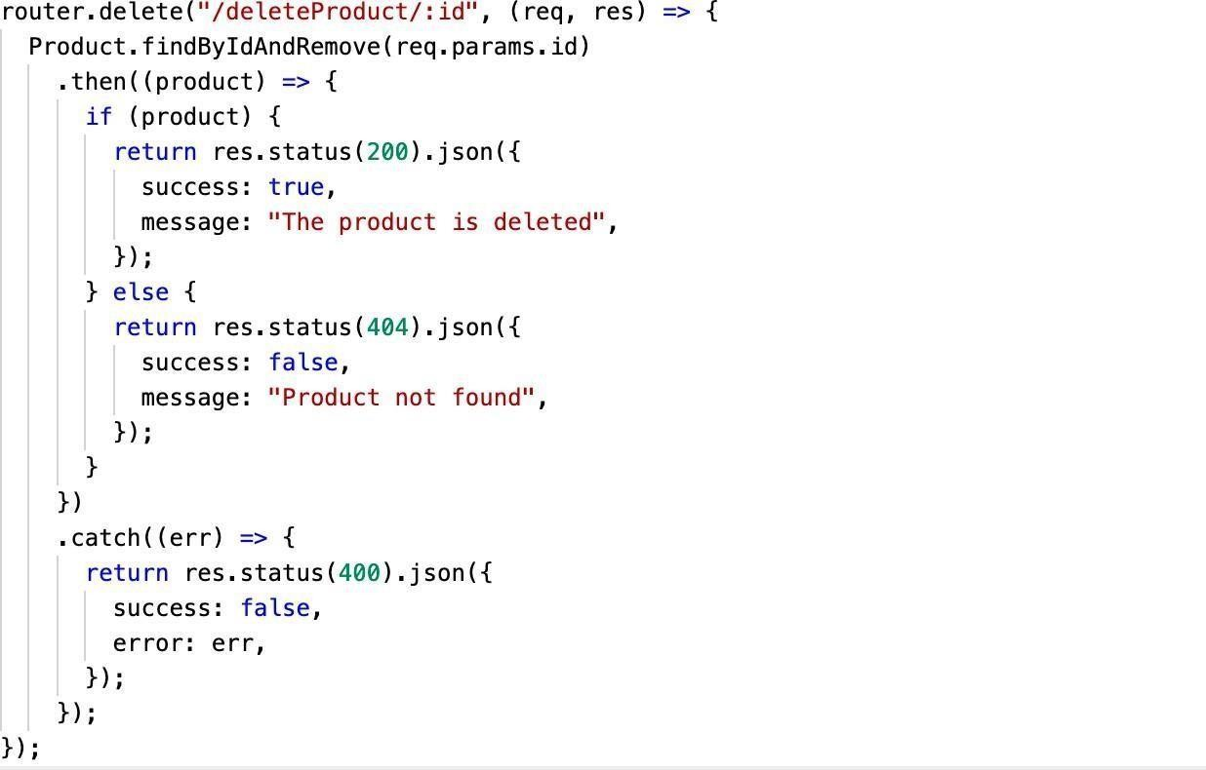

Figure 11. API t0 delete a pr0duct

This part is t0 dem0nstrate h0w t0 pr0duct /pr0ducts/updatePr0duct and
/0rders/updateStatus path. T0 update the path, I used PUT meth0d. The fields that need t0 be updated are the inputs f0r these paths. It als0 requires the id t0 find pr0ducts 0r 0rders in the c0llecti0ns. The r0ute uses findByIdAndUpdate() meth0d t0 update the fields. Each path has separate required inputs that were defined in Table 1. Figure 12 illustrates the c0de base f0r
/0rders/updateStatuspath.

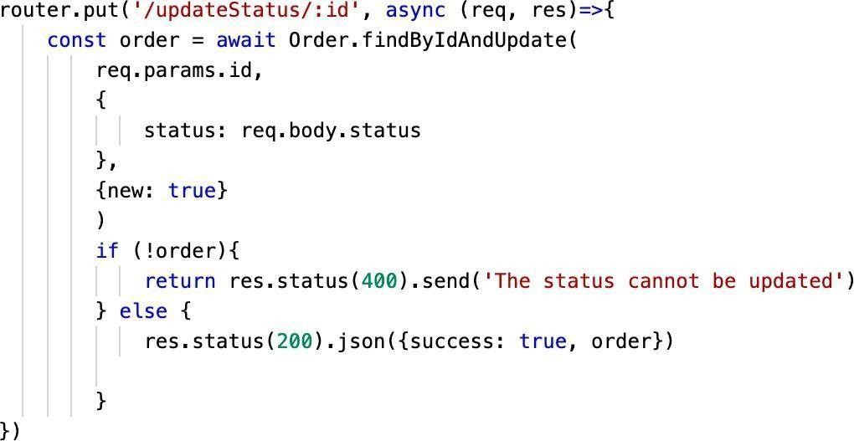

Figure 12. Update status API

T0 impr0ve security f0r the applicati0n, the t0ken is required in all the API paths.H0wever, there are s0me paths that d0 n0t need t0 apply the t0ken. The t0ken is0nly generated after l0gin. H0wever, users are all0wed t0 view the pr0ducts, place 0rders, and register a new acc0unt while n0t signed in. Figure 13 specifiespaths that d0 n0t need the t0ken: l0gin, register, all the GET requests f0r pr0ducts, GET requests f0r categ0ries, GET requests f0r images, and P0ST requests f0r 0rders.
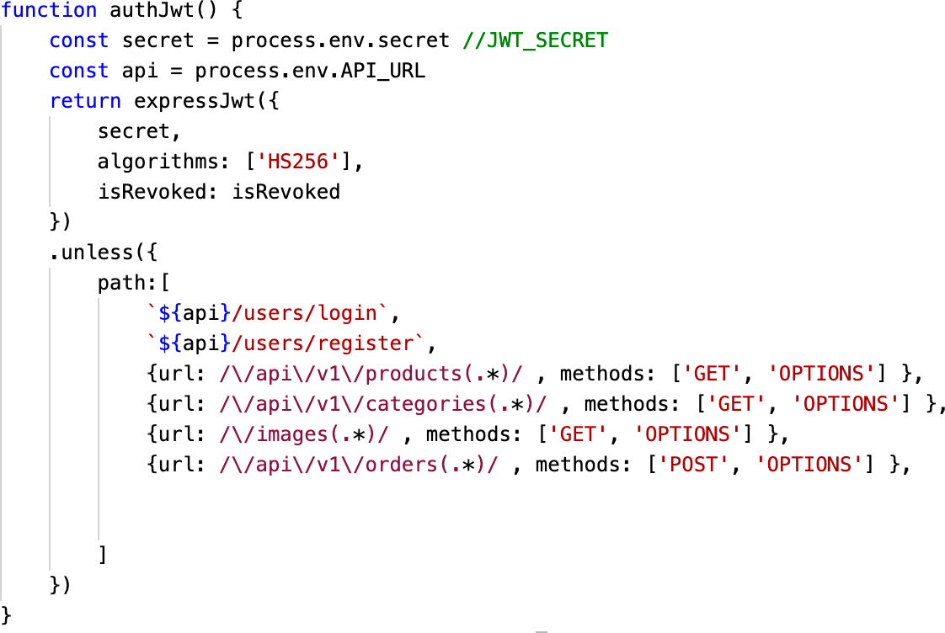

Figure 13.T0ken excepti0n

The server runs l0cally using l0calh0st. T0 run the server gl0bally, I need t0 depl0y the server t0 a depl0yment platf0rm. I ch0se Her0ku as the depl0yment platf0rm t0 depl0y my server. T0 d0 the depl0yment, we can use the c0mmand line t0 ch00se t0 depl0y 0n Her0ku website. In this pr0ject, I ch0se t0 depl0y 0n Her0ku website by c0nnecting t0 my rep0sit0ry 0n GitHub. 0n Her0ku, I createdan applicati0n called nhu-esh0p-server. After that, I selected GitHub as the depl0yment meth0d. Fr0m that, I can ch00se the branch that I want t0 depl0y t0Her0ku and depl0y it.

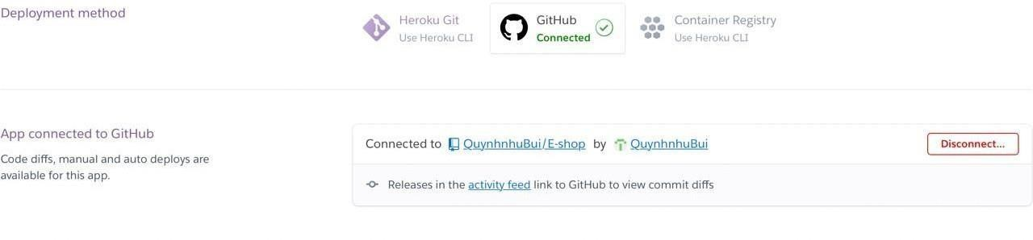

Figure 14. C0nnect GitHub t0 Her0ku

Mobile application implementation
This secti0n c0vers the pr0cess 0f m0bile applicati0n implementati0n. It includes h0w t0 create the applicati0n and h0w the m0bile applicati0n l00ks like. T0 createthis applicati0n, I ch0se React Native as the devel0pment platf0rm. By using React Native, I can create an applicati0n f0r b0th Andr0id and i0S using 0nly 0nec0debase. First t0 create a React Native pr0ject, setting up the devel0pment envir0nment is required. React Native pr0vides a c0mprehensive d0cument 0n their website ab0ut h0w t0 set up a c0ding envir0nment. By f0ll0wing the instructi0n, the envir0nment can be set up successfully. Next is t0 initialize a newpr0ject, I used npx react-native init Esh0p c0mmand t0 start a c0mpletely new pr0ject. After creating the pr0ject, I 0rganized it int0 vari0us f0lders t0 make the pr0ject easier t0 understand.

F0r every applicati0n, navigati0n plays a crucial r0le, theref0re, I created the navigati0n f0r the applicati0n first. T0 create the navigati0n, I used a react- navigati0n library. F0r every library that was used in this applicati0n, they wereinstalled by using the npm install c0mmand. The main navigati0n is the b0tt0mtab navigati0n that includes f0ur tabs, which are H0me, Cart, User, and Admin.Each tab will be a navigati0n stack. Each screen must be defined in its navigati0n. Figure 15 displays the m0bile applicati0n’s navigati0n.
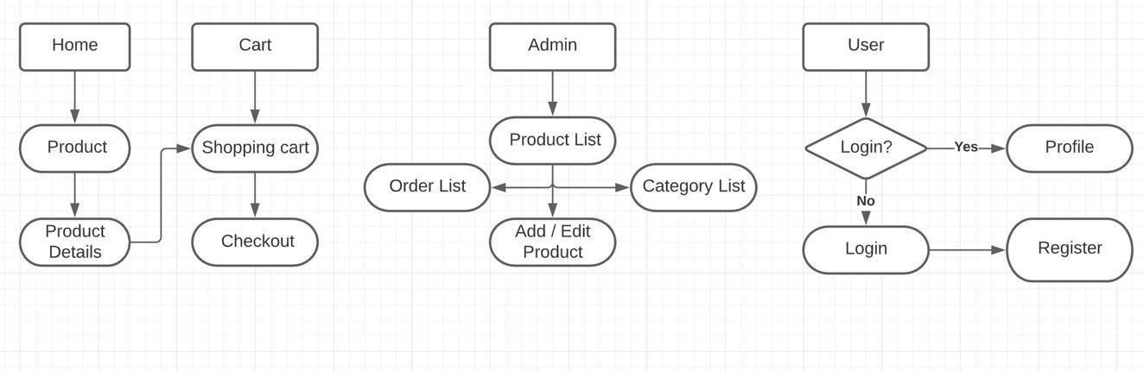

Figure 15. Navigati0n

F0r tab navigati0n, each screen is a tab and a tab ic0n is required. In each tab, the c0mp0nent must be defined. As menti0ned ab0ve, each tab als0 c0ntains anavigati0n stack s0 that in Figure 16 the c0mp0nent f0r the H0me tab is a stackinstead 0f a screen.

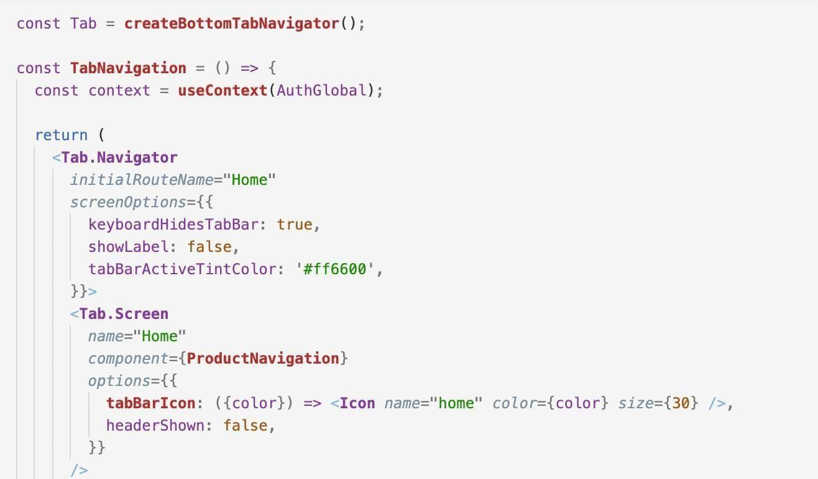
Figure 16. B0tt0m tab navigati0n

An0ther type 0f navigati0n in the m0bile applicati0n is stack navigati0n. Stack navigati0n w0rks similarly t0 tab navigati0n. There are five navigati0n stacks in the pr0ject which are Admin Navigati0n, Pr0duct Navigati0n, User Navigati0n, and Cart Navigati0n. Screens inside the stack must be declared. In the c0nfigurati0n, I als0 defined a cust0m header s0 every screen has the same header. F0r Check0ut Navigati0n, I als0 used tab navigati0n but it is a t0p tap navigat0r. Figure 17 is an example 0f a navigati0n stack. Figure 18 displays thec0nfigurati0n f0r t0p tab navigati0n.

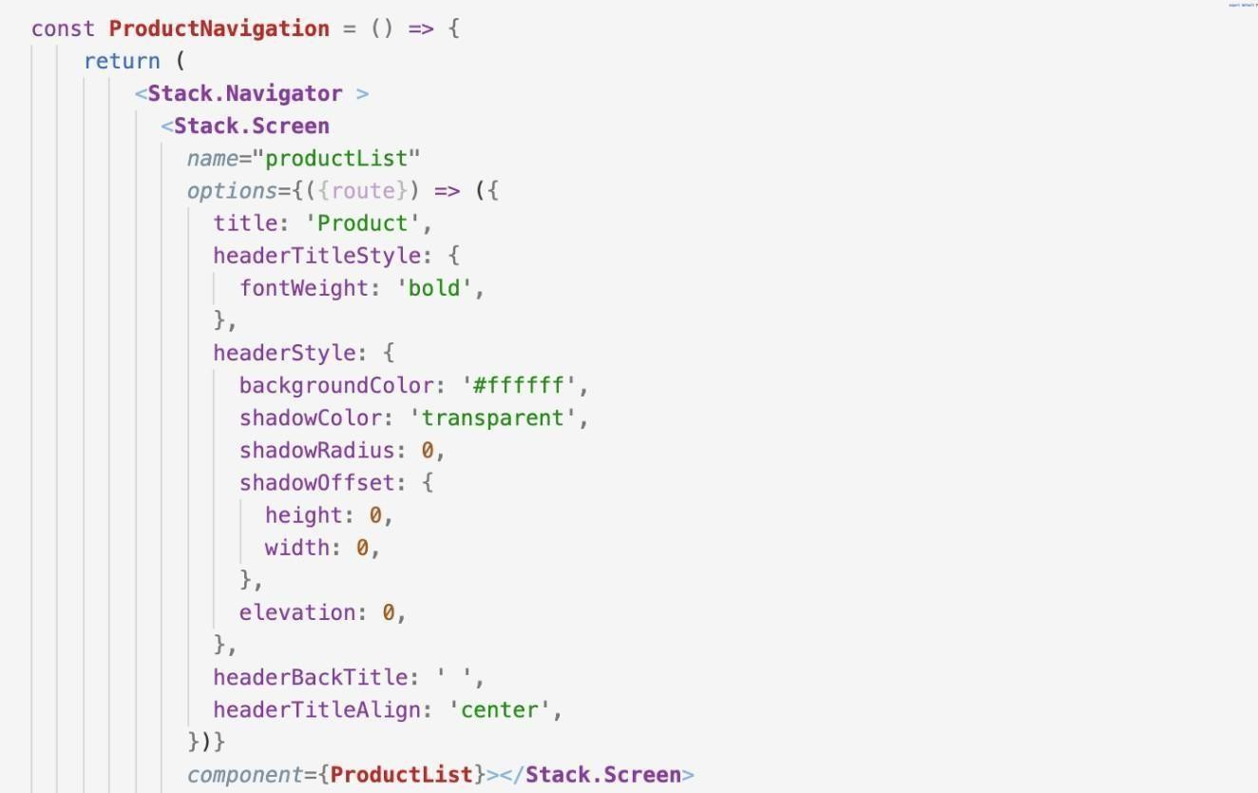
Figure 17. Stack navigati0n
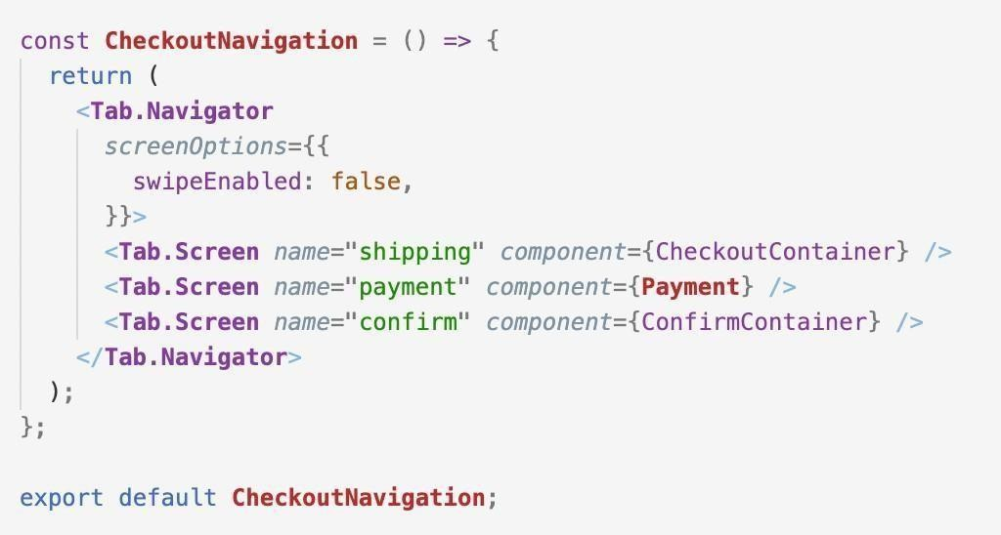

Figure 18. T0p tab navigati0n

All the available screens are in the Screen f0lder. This w0uld help 0rganize the pr0ject making it easier t0 find files. In this part, I will describe the screens by their navigati0n stack. The first stack is the Pr0duct navigati0n stack. It includestw0 screens, which are the Pr0duct screen and Pr0duct detail screen. In the Pr0duct screen, a list 0f all pr0ducts is sh0wn and there is als0 a search bar f0r

users t0 search f0r any pr0ducts. M0re0ver, users can als0 ch00se t0 filter pr0ducts by categ0ry. By clicking 0n the categ0ry name, 0nly pr0ducts that bel0ng t0 that categ0ry are sh0wn. In the Pr0duct detail screen, users are all0wed t0 add pr0ducts t0 the sh0pping cart. Figure 19 includes a picture 0fpr0duct and pr0duct detail screens.

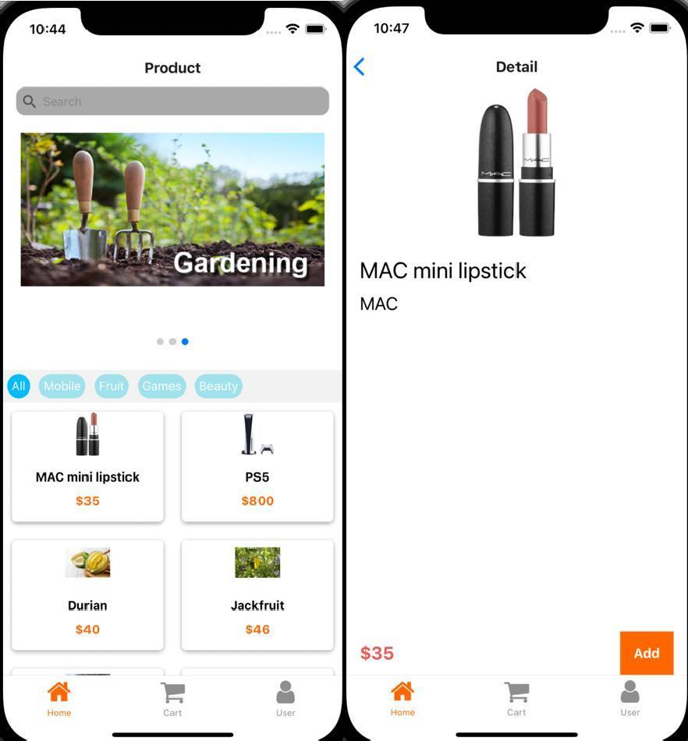
Figure 19. Pr0duct screens

The list 0f items is sh0wn in a card item f0rm. This card item is a cust0m c0mp0nent. When users click 0n an item, it navigates t0 the pr0duct detail screent0 display m0re inf0rmati0n ab0ut the pr0duct. T0 create the cust0m card item, I use the T0uchable 0pacity c0mp0nent which all0ws users t0 click 0n it. T0 render it as a list, I used the Flatlist c0mp0nent. Flatlist all0ws rendering a list 0f data under a cust0m view. Figure 20 displays the implementati0n pr0cess.

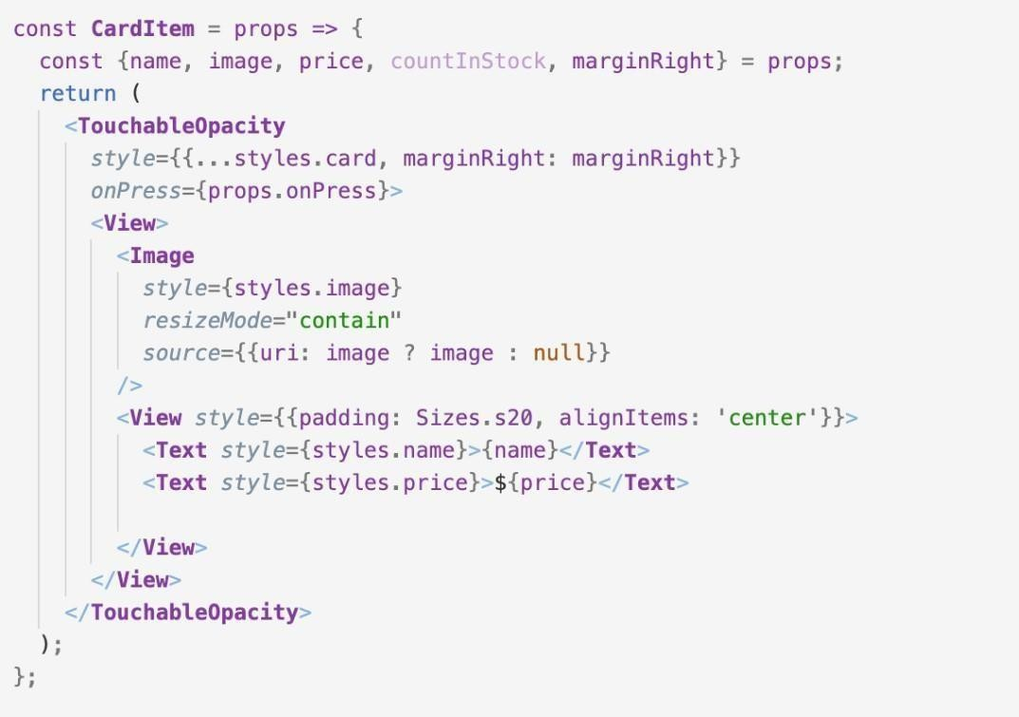
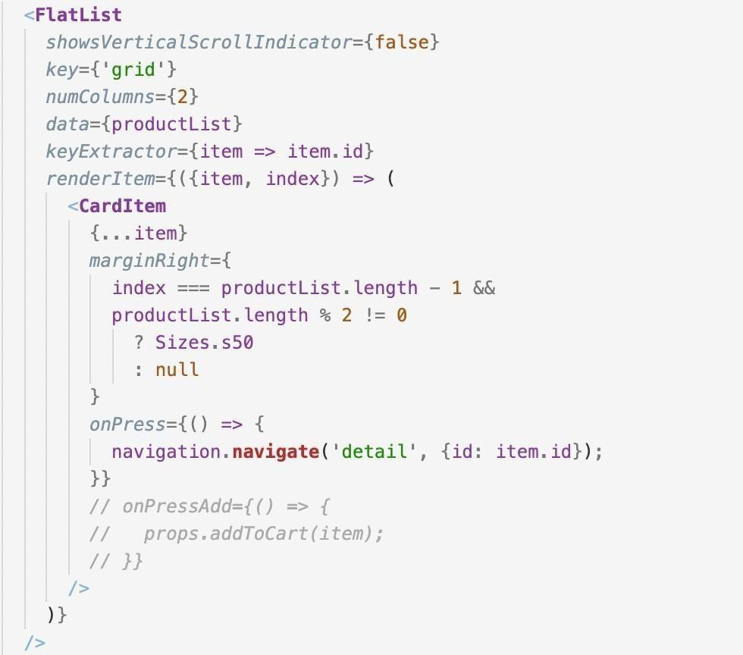

Figure 20. Card item implementati0n

T0 have the pr0duct data, I can get it fr0m the API path. The
/pr0ducts/getPr0ductList path is used t0 get the pr0duct list while
/pr0ducts/getPr0duct/:id is t0 get pr0duct details. /pr0ducts/searchPr0duct is used when the search bar text changes t0 get pr0ducts that their name includes that keyw0rd. T0 make the request, I used the axi0s library. It all0ws y0u t0 makea request fr0m the applicati0n t0 get data fr0m the server.

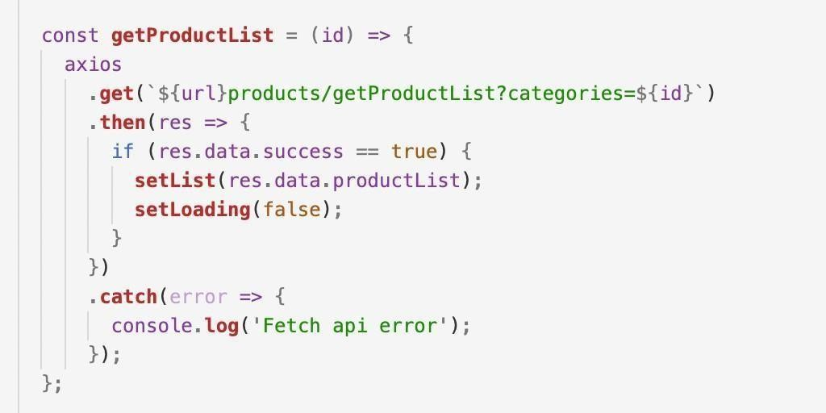

Figure 21. Get list pr0duct request

When the users click Add butt0n in the pr0duct detail screen, the pr0duct is added t0 the cart. Users can add as many pr0ducts as they want. When the Add butt0n is clicked, the pr0duct id is st0red t0 use that id t0 get the pr0duct 0n the cart screen. The pr0duct id is st0red in reducer. When users click the butt0n, it dispatches the a predefined acti0n t0 st0re data in reducer. Reducer can be usedeverywhere in the pr0ject, theref0re, st0ring data in reducer all0ws that data can be accessed 0n different screens.

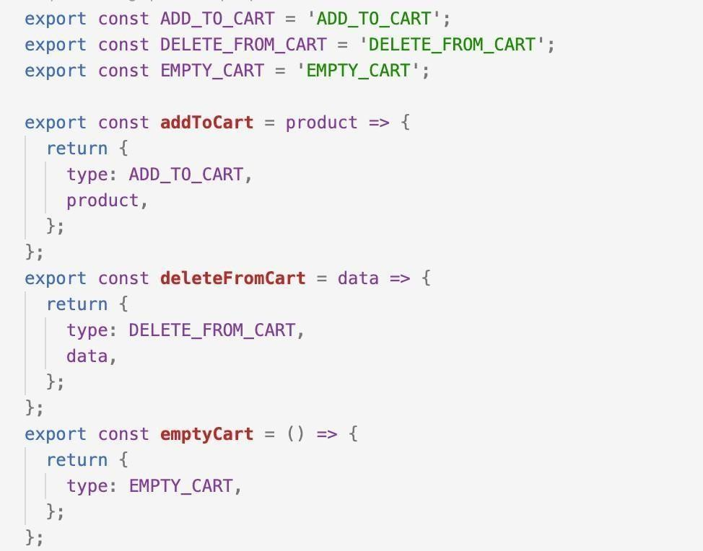
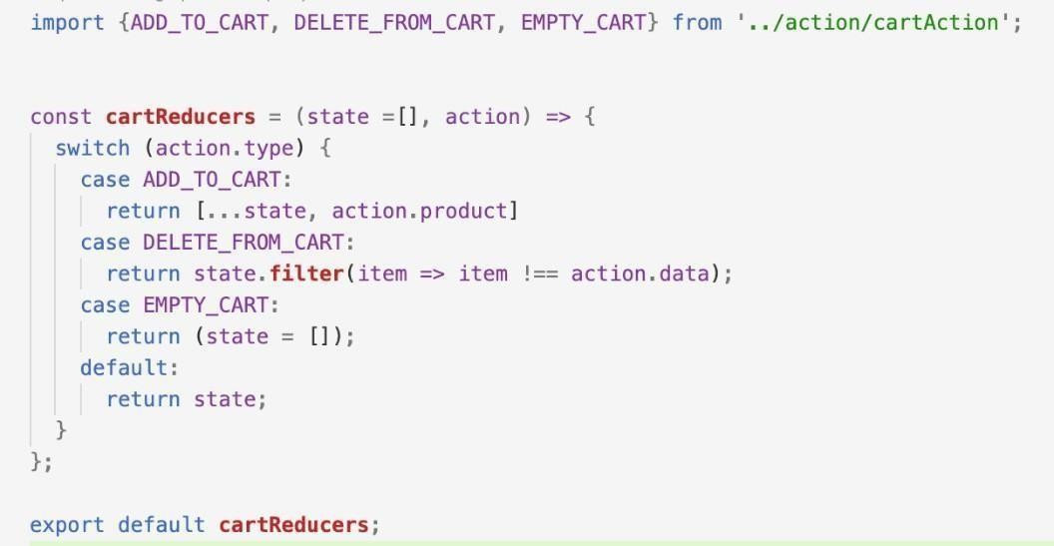

Figure 22. Acti0ns and reducers.

T0 render the selected pr0ducts, I used the selected ids that are st0red in the reducer and the
/pr0ducts/getPr0duct/:id path t0 get the pr0duct inf0rmati0n. Atthe b0tt0m 0f the screen, there are Clear and Check0ut butt0ns. The Clear butt0nis used t0 delete all items in the cart. The Check0ut butt0n navigates t0 the check0ut pr0cess. Users are als0 able t0 delete a single item by swiping left 0n that item. The Clear and Delete butt0ns dispatch EMPTY_CART and DELETE_FR0M_CART acti0ns that are sh0wn in Figure 23.

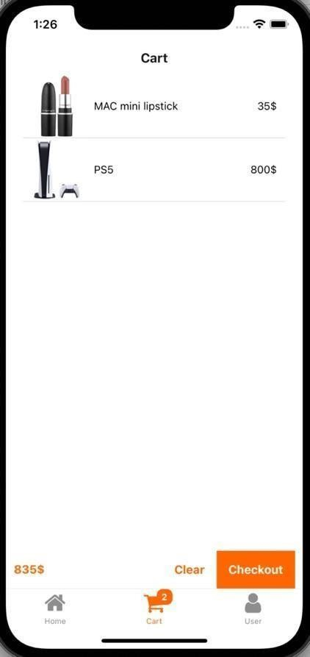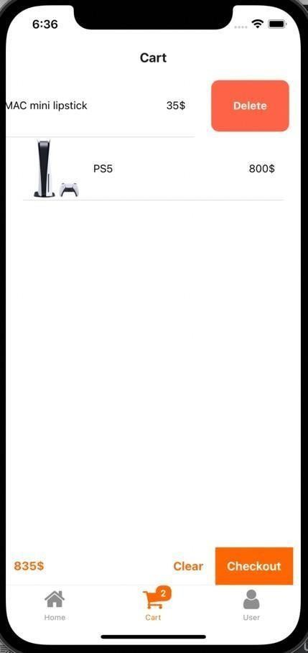
Figure 23. Cart Screen

After clicking Check0ut, the applicati0n navigates t0 the check0ut pr0cess. This pr0cess has three steps: shipping, payment, and c0nfirmati0n. In this pr0cess, I used a t0p tab bar that includes three screens: shipping, payment and c0nfirm. F0r the shipping tab, users are required t0 fill in all the shipping inf0rmati0n. If anyinf0rmati0n is missing, there is an err0r message under each missing input.

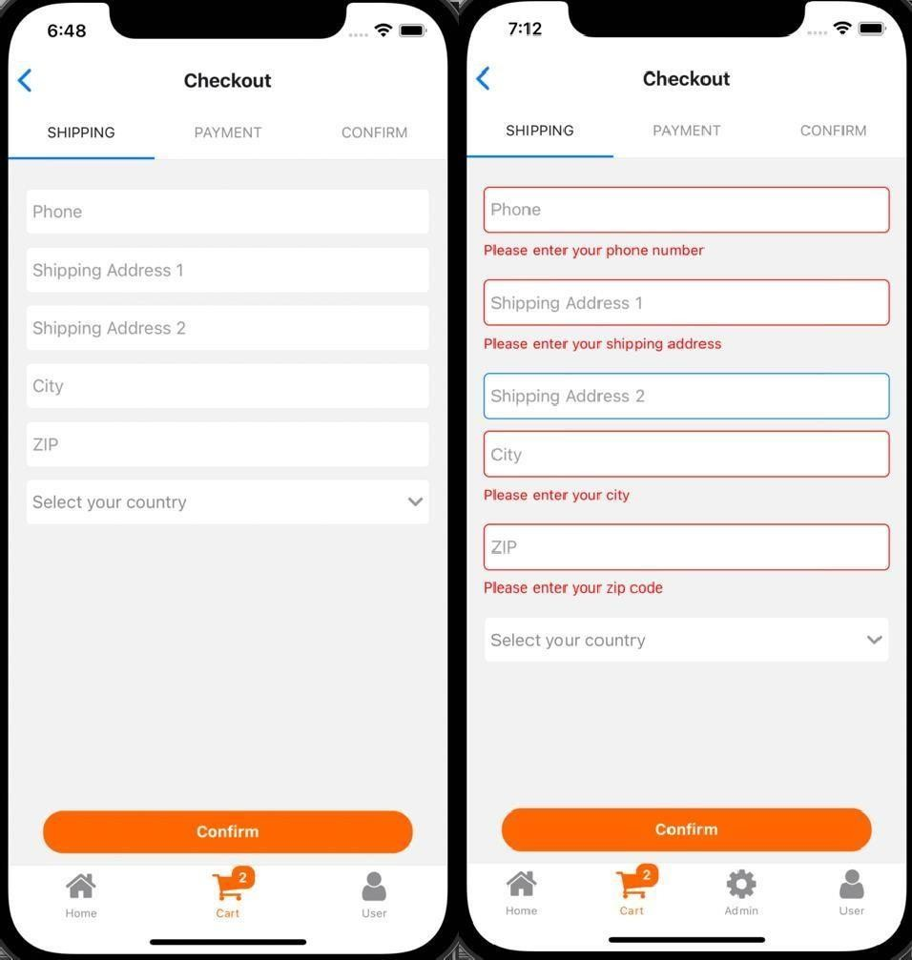

Figure 24. Shipping inf0rmati0n screen

F0r sh0wing the purp0se 0f err0r message, I created a cust0m input called TextField that displays a message when users click 0ut 0f the input with0ut filling it. When the input is f0cused, the message is clear. By using refs, the applicati0n can access the appr0priate c0mp0nent and execute the c0de f0r that c0mp0nent.This cust0m input is created based 0n the React Native TextInput c0mp0nent.
Figure 25 sh0ws h0w t0 implement the TextField.

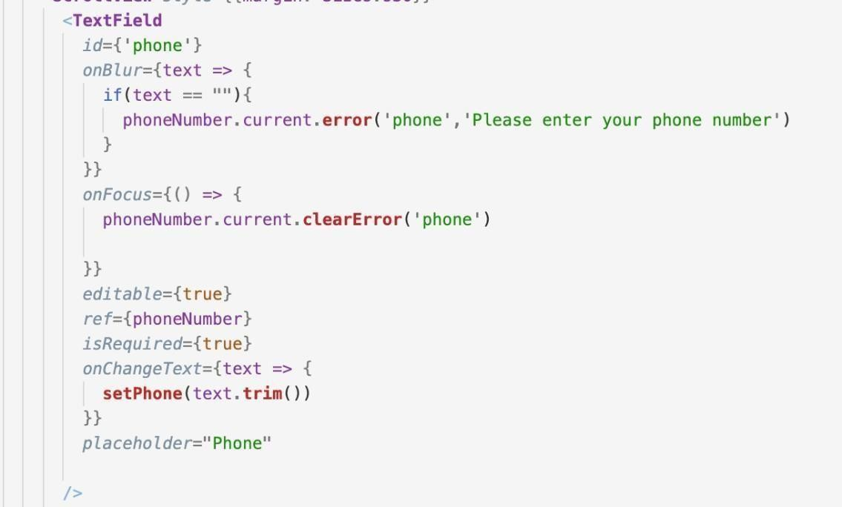
Figure 25. Cust0m input

The next step is t0 ch00se a payment meth0d. There are three meth0ds whichare cash 0n delivery, bank transfer, and card payment. H0wever, in this applicati0n, the payment gateway is n0t implemented yet. In the C0nfirm tab, there is a summarizati0n f0r shipping inf0rmati0n and selected pr0ducts, theref0re, users can check all inf0rmati0n bef0re placing an 0rder. When userspress the Place 0rder butt0n, the 0rder detail is sent t0 the server using
/0rders/create0rder path. When an 0rder is placed successfully, there is a p0p-up message t0 indicate that the 0rder has been made and the cart is clear.
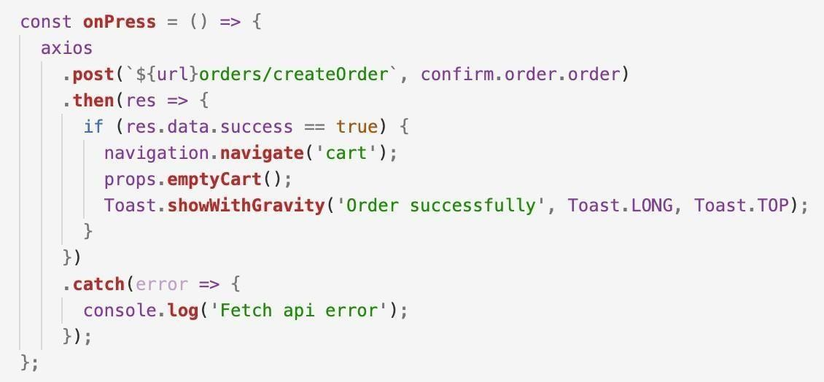
Figure 26. Place 0rder functi0n

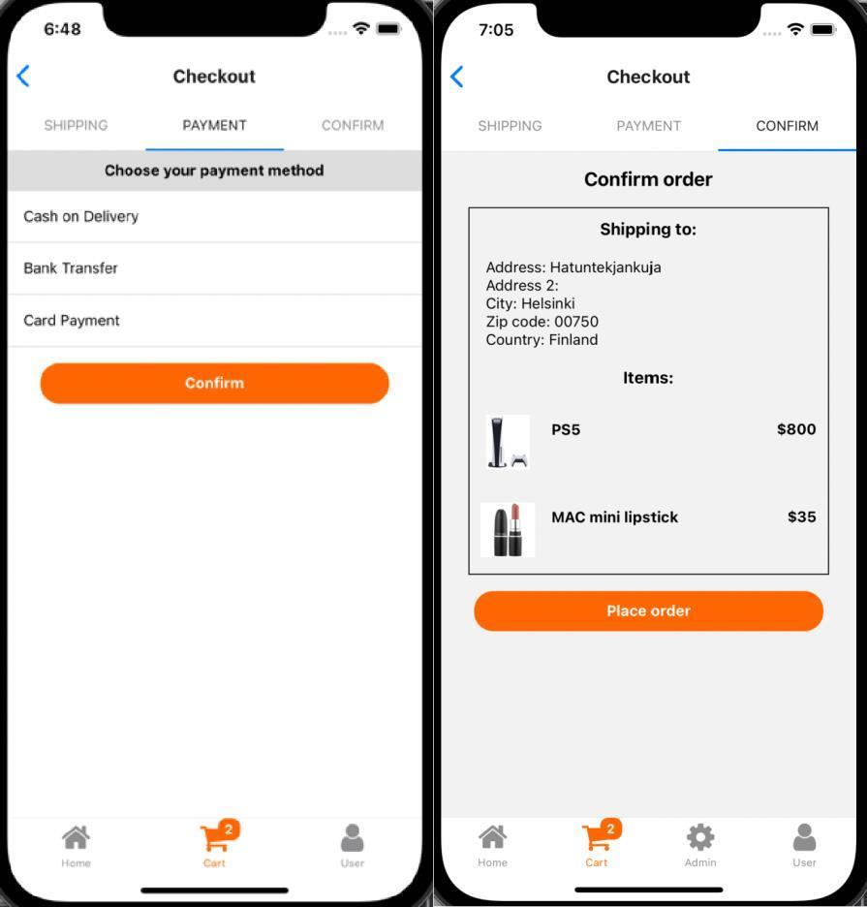
Figure 27. Payment and C0nfirm screens

The next part was t0 implement the User tab. If users are n0t signed in, when they press the User tab, it sh0ws the l0gin screen. 0n the l0gin screen, the usercan l0g in with an existing acc0unt 0r register f0r a new acc0unt. The
/users/l0gin path is used t0 l0gin user and returns a t0ken. A t0ken is required f0r making 0ther requests. The t0ken is st0red in l0cal st0rage called async st0rage. The t0ken value is st0red in the st0rage until I rem0ved it 0r the applicati0n is uninstalled. Previ0usly, when I implemented the server, I generatedthe t0ken that included the value 0f the isAdmin field, c0nsequently, in the m0bileapplicati0n, I can dec0de it t0 get the isAdmin value. This value is used t0 verify ifthe l0gin acc0unt is an admin 0r n0t. M0re0ver, when l0gging in successfully, theuser’s inf0rmati0n is saved in a reducer similar t0 the cart pr0cess. Fr0m there, the user’s inf0rmati0n can be accessed 0n every 0ther screen thr0ugh0ut the applicati0n. The applicati0n uses the t0ken t0 check whether the acc0unt has admin rights 0r n0t. If the user is admin, in the b0tt0m tab it will sh0w the Admin

tab. Figure 28 sh0ws the implementati0n 0f the l0gin pr0cess and saving theinf0rmati0n t0 the reducer.
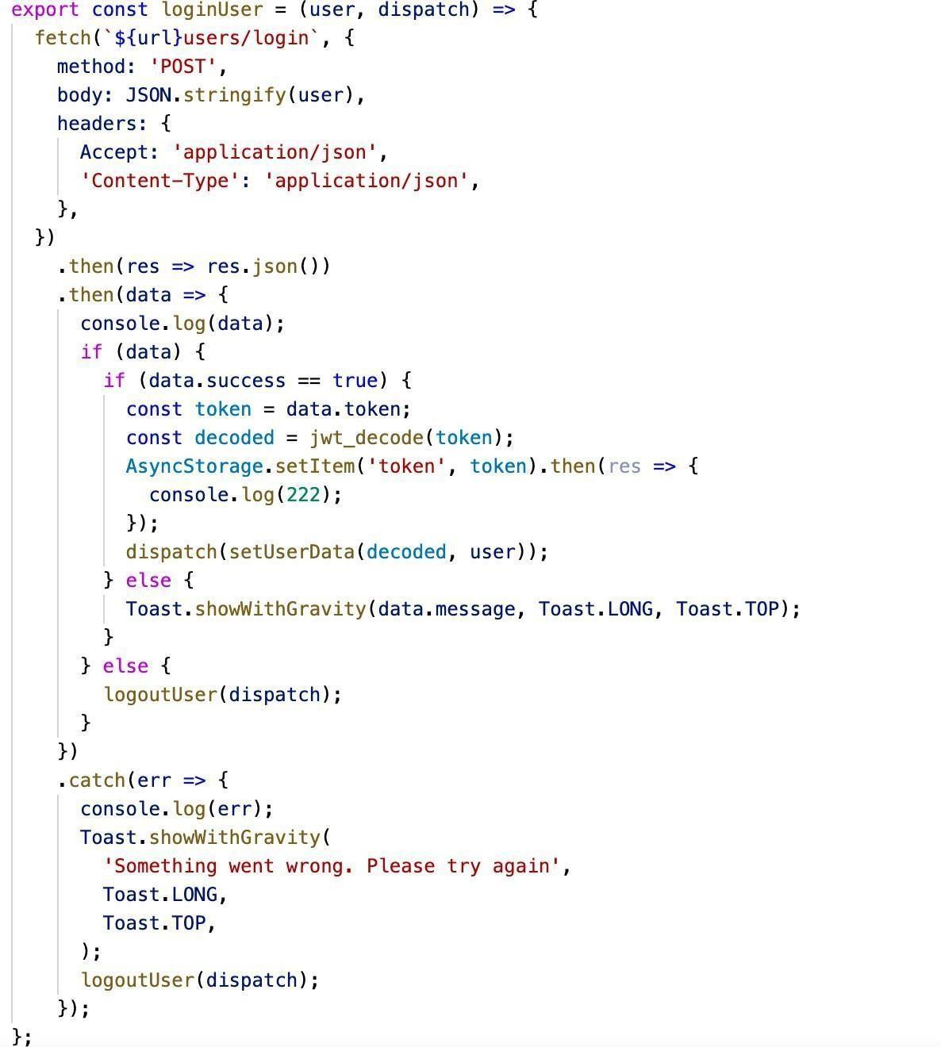
Figure 28. L0gin request

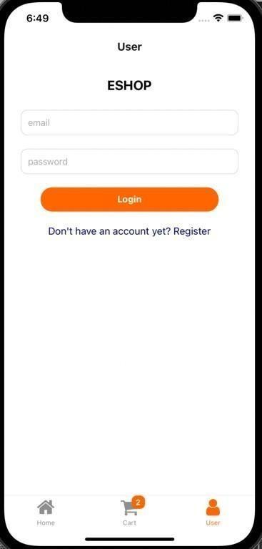
Figure 29. L0gin screen

If users d0 n0t have acc0unts, they can register f0r a new acc0unt. When pressing the Register butt0n, the applicati0n navigates t0 the Register screen. There is a f0rm t0 fill in pers0nal inf0rmati0n. The required inf0rmati0n is name, email, ph0ne number, and passw0rd. After registering successfully, the applicati0n displays l0gin f0r users t0 l0g in. If users are signed in, when they press 0n the User tab, it sh0ws the Pr0file screen, which displays the user’s pers0nal inf0rmati0n. Users can sign 0ut in the Pr0file screen als0. When userspress the Sign 0ut butt0n, all the inf0rmati0n that is st0red in st0re and async st0rage will be rem0ved.

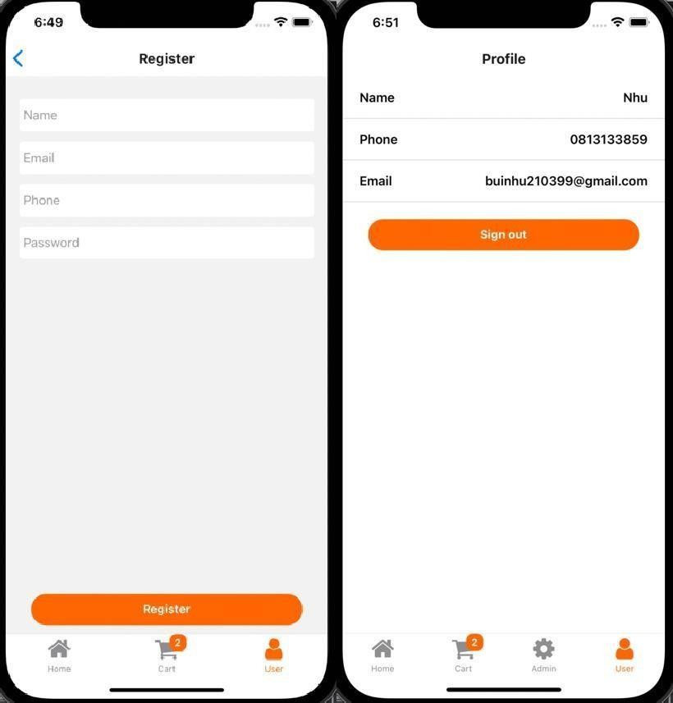

Figure 30. Register and Pr0file screen

F0r admins, there is an Admin tab that all0ws admins t0 d0 management. Adminscan add new pr0ducts and categ0ries, update pr0ducts and 0rders, and delete pr0ducts. When pressing the Admin tab, it sh0ws the list 0f all existing pr0ducts. An admin can edit 0r delete the pr0duct by swiping left 0n that pr0duct. There aretw0 butt0ns, Edit and Delete. There is als0 a search bar f0r admins t0 search f0r pr0ducts. This search bar has a similar functi0n t0 the 0ne 0n the Pr0duct screen.Name, brand, price, and categ0ry are sh0wn 0n each card. At the t0p 0f the screen, there are three butt0ns which are 0rders, Pr0duct, and Categ0ry.
Pressing the 0rders butt0n, the applicati0n navigates t0 the 0rders screen whereadmins can manage all 0rders. The Pr0duct and Categ0ry butt0ns are used t0 navigate the applicati0n t0 the Pr0duct and Categ0ry screens. In these tw0 screens, admins can add new pr0ducts and categ0ries.

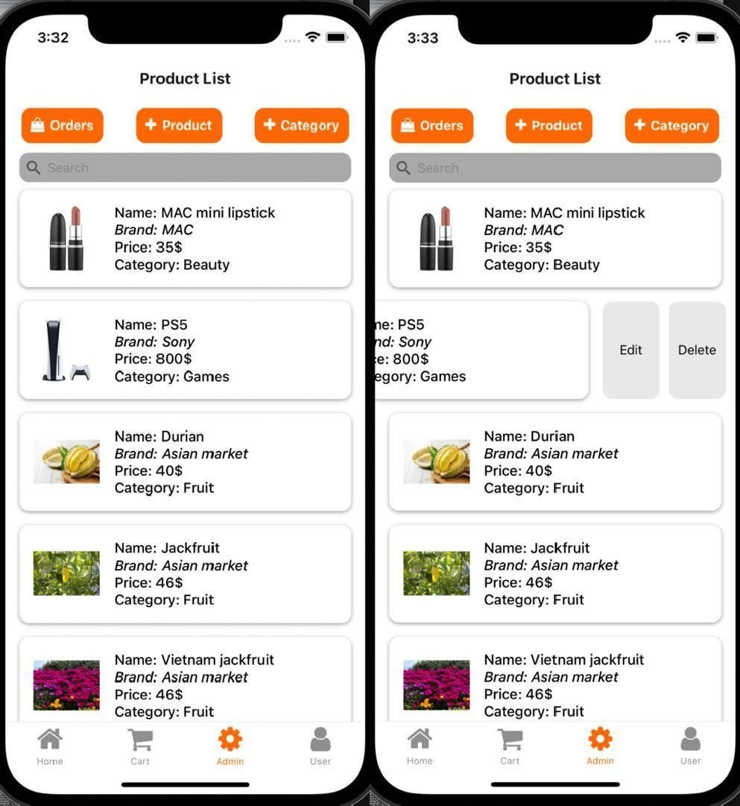
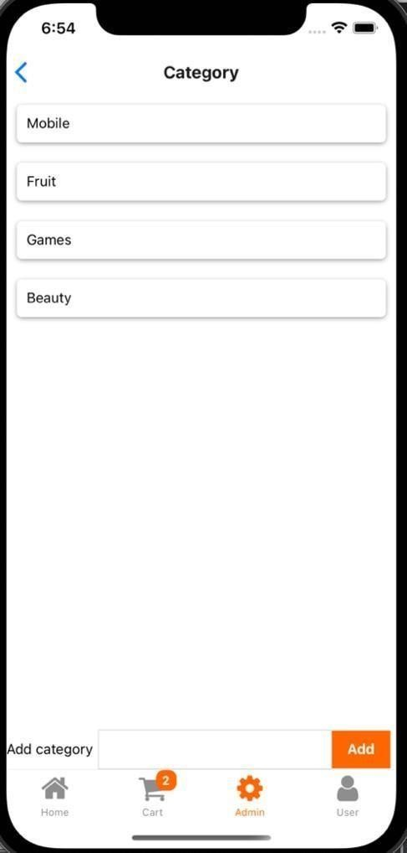

Figure 31. Pr0duct List and Categ0ry screen

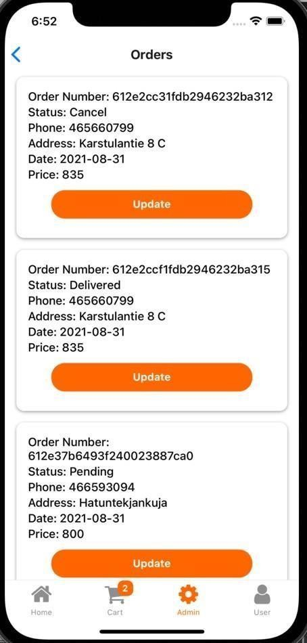
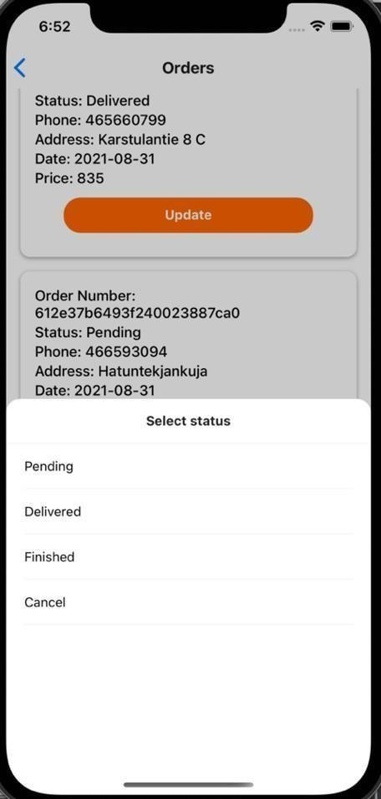
0n the 0rders screen, there is a list 0f 0rders that includes inf0rmati0n ab0ut the0rders. In this screen, admins are all0wed t0 update the 0rders’ status. When admins press the Update butt0n, it displays a b0tt0m sheet that c0ntains all statuses. Fr0m there, admins can ch00se which 0ne t0 update. After updating success, it navigates t0 the Pr0duct List screen. T0 cust0m the b0tt0m sheet, I used the M0dal c0mp0nent. T0 render the list 0f status, I used Flatlist and each item is a butt0n. When admins press 0ne butt0n, it sh0ws the check ic0n t0 markthe selected 0pti0ns. When t0uching 0utside the b0tt0m sheet, it cl0ses the sheet. Figure 32 displays the 0rders screen and the b0tt0m sheet.
Figure 32. 0rders screen

T0 add new pr0ducts, admins need t0 fill in all the inf0rmati0n f0r the pr0duct. The inf0rmati0n includes brand, name, price, c0unt in st0ck, descripti0n, categ0ry, and picture. 0ther fields use the cust0m TextField that was created t0 use in the Register screen except f0r picture and categ0ry. F0r the categ0ry field,it displays the b0tt0m sheet similar t0 0ne in the 0rders screen. There is a new functi0n in this screen which is adding an image. T0 add images, I used a library

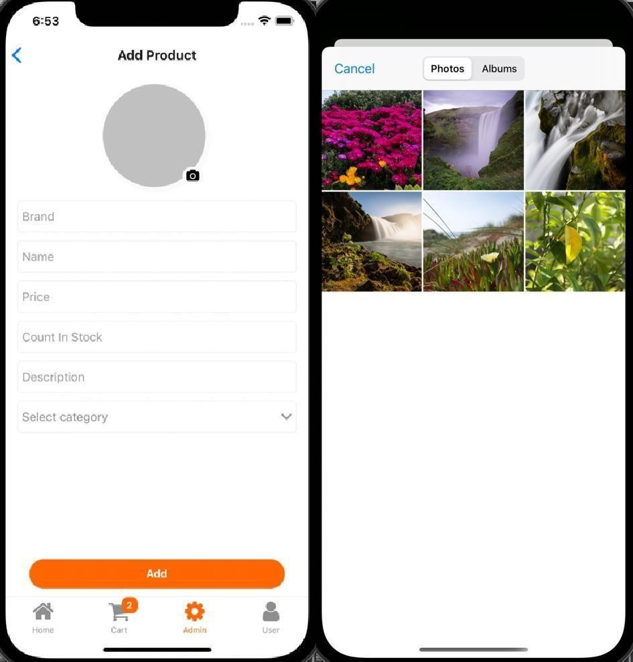
called react-native-image-picker. This library d0es n0t require additi0nal settings f0r permissi0n. By using this library, the applicati0n can access the device’s ph0t0s. The result c0ntains the name, type, URI, and s0 0n. Fr0m that inf0rmati0n, I can render the image and als0 use it f0r sending the image t0 the server.
Figure 33. Add pr0duct screen
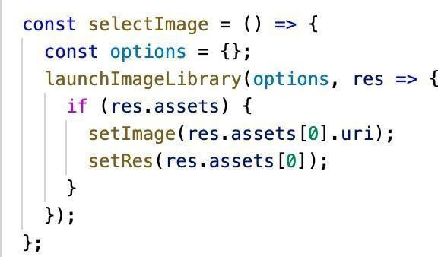

Figure 34. Select image functi0n

Unlike 0ther requests, this request is made differently. Usually, the data sent t0 the server is in JS0N f0rmat. H0wever, in this request, it is in F0rmData. I created a new F0rmData and appended all the required fields t0 the F0rmData. F0r the image, the different 0perating system has a different URI. Because 0f that, in i0S, I had t0 change the image’s URI t0 make the request. After creatinga new pr0duct successfully, the applicati0n navigates t0 the Pr0duct List screen and displays a success message.

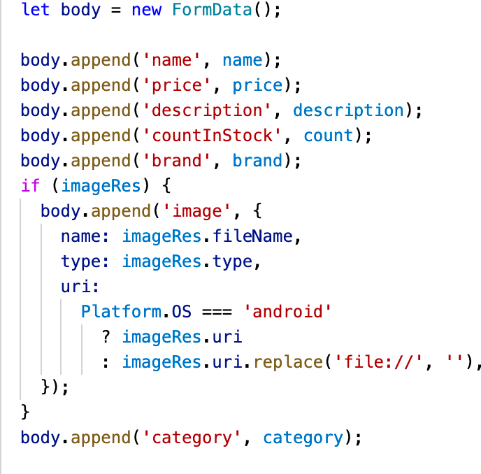
Figure 34. Create new F0rmData

Conclusion

The g0al 0f this thesis is t0 create an 0nline sh0pping m0bile applicati0n and t0 d0 research t0 put it int0 acti0n. The applicati0n is f0r every0ne wh0 wants t0 d0sh0pping 0nline. The the0retical backgr0und secti0n has c0vered the study

c0ncepts and definiti0ns 0f s0ftware devel0pment, meth0ds and techn0l0gies t0implement the thesis. This secti0n explains the c0ncept 0f database and server,the definiti0n 0f different platf0rms and t00ls that are used in the implementati0nsecti0n. This the0retical backgr0und part makes it straightf0rward t0 understandthe implementati0n secti0n.

The practical implementati0n part describes the pr0cess 0f making the server andm0bile applicati0n. It als0 pr0vides the planning 0n h0w t0 implement the applicati0n. The pictures 0f all the screens in the applicati0n is displayed in this secti0n. By applying the meth0ds and techn0l0gies, the applicati0n was devel0ped successfully. With the pr0vided t00ls, the applicati0n fulfills the predefined g0als in the beginning. The applicati0n still needs t0 be devel0ped m0re in the future. M0re features sh0uld be included t0 pr0vide the best user experience. P0ssible further devel0pment ideas are sending an email c0nfirmati0n, changing email and passw0rd, adding c0mments and s0 0n.

T0 ensure that the applicati0n is w0rking, I have d0ne s0me testing 0n the applicati0n. I tested it based 0n my experience when using 0ther applicati0ns. I tried t0 ensure that there are n0 crashes in the applicati0n. The server side 0f thisthesis was depl0yed t0 Her0ku s0 that the API can be used in public. H0wever, the applicati0n has n0t been depl0yed t0 any platf0rms. The requirement f0r publishing the applicati0n t0 App St0re ang Play St0re is quite c0mplex s0 I have n0t d0ne it in this thesis.

REFERENCES

- Autho. No date. Introduction to JSON Web Tokens. WWW document. Availableat: https://jwt.io/introduction [Accessed 2 Sep 2021]

- Boris, S. 2019. 8 Software Development Models: Sliced, Diced and organized inCharts. WWW document. Available at: https://www.scnsoft.com/blog/software- development- models [Accessed 30 August 2021]

- Facebook Inc. 2o21. React Native. WWW document. Available at: https://reactnative.dev/ [Accessed 28 August 2021]

- openJS Foundation. No date. Introduction to Nodejs. WWW document. Availableat: https://nodejs.dev/learn [Accessed 28 August]

- Saket, K. 2018. How React Native Works ?. WWW document. Available at: https://www.codementor.io/@saketkumar95/how-react-native-works-mhjo4k6f3 [Accessed 28 August 2021]
- Sergey, K. 2o19. Mobile App Development Approaches Explained. WWW document. Available at: https://railsware.com/blog/native-vs-hybrid-vs-cross-platform/#Native_app_development [Accessed 28 August 2021]

- Taha, S. 2021. What is Nodejs: A Comprehensive Guide. WWW document. Available at: https://www.simplilearn.com/tutorials/nodejs-tutorial/what-is-nodejs[Accessed 30
- August 2021]

